Indicate the answer choice that best completes the statement or answers the question.

1. A community
 | a. | includes all populations of all species in a given area.
 | b. | features the living organisms interacting with the physical and chemical environment.
 | c. | is the sum of all places in Earth's atmosphere, crust, and waters where organisms live.
 | d. | includes members of only one species.
 | e. | is at a higher level of organization than an ecosystem.

2. Randomly selecting samples of experimental units from an environment can result in __________________.
 | a. | sampling error
 | b. | blind testing
 | c. | evidence
 | d. | experimental design
 | e. | consensus

3. Science is based on ___________.
 | a. | faith
 | b. | authority
 | c. | evidence
 | d. | force
 | e. | opinion

4. Members of which prokaryotic domain are most closely related to eukaryotes evolutionarily?
 | a. | Animals
 | b. | Protists
 | c. | Fungi
 | d. | Bacteria
 | e. | Archaea

5. Which group of organisms does not depend directly on sunlight for energy?
I. Terrestrial producers
II. Animal consumers
III. Decomposers
 | a. | I only
 | b. | II and III only
 | c. | II only
 | d. | III only
 | e. | I and III

6. The most inclusive level of organization is exemplified by which of the following?
 | a. | Heart
 | b. | Carbon atom
 | c. | DNA
 | d. | Zebra
 | e. | Red blood cell

7. The process by which the first cell of a new individual gives rise to a multicell adult is called _______.
 | a. | reproduction
 | b. | development
 | c. | growth
 | d. | inheritance
 | e. | homeostasis

8. The plural for genus is ________.
 | a. | genus
 | b. | geni
 | c. | genera.
 | d. | gena
 | e. | genae

9. Each cell is able to maintain an internal environment within a range that favors survival. This condition is called ___________.
 | a. | metabolism
 | b. | homeostasis
 | c. | physiology
 | d. | adaptation
 | e. | evolution

10. The choice of whether a particular organism belongs to the experimental group or the control group should be based on ___________.
 | a. | age
 | b. | size
 | c. | chance
 | d. | history
 | e. | gender

11. In an experiment, the control group is __________.
 | a. | not subjected to experimental error
 | b. | exposed to experimental treatments
 | c. | maintained under strict laboratory conditions
 | d. | treated exactly the same as the experimental group, except for one variable
 | e. | statistically the most important part of the experiment

12. Which of the following is used by all living things as the carrier of genetic information?
 | a. | Cell
 | b. | DNA
 | c. | Organ
 | d. | Molecule
 | e. | Population

13. What is an acceptable probability of sampling error that may have skewed the results in most scientific studies?
 | a. | 80%
 | b. | 50%
 | c. | 25%
 | d. | 10%
 | e. | 5%

14. The flow of energy through living organisms is best characterized as ___.
 | a. | circular
 | b. | increasing
 | c. | a lattice
 | d. | one way
 | e. | lossless

15. Which of the following is NOT true about the peacock butterfly?
 | a. | The dark underside of their wings provides camouflage.
 | b. | The spots on the wings may resemble owl eyes, which help deter predation.
 | c. | The butterflies remain still when a predator is near so as not to draw attention.
 | d. | The rapid movement of their wings produces a hissing sound.
 | e. | A resting butterfly’s closed wing resembles a dead leaf.

16. Energy sources are needed for which of the following processes?
I. Reproduction
II. Growth
III. Development
 | a. | I and II only
 | b. | I and III only
 | c. | II only
 | d. | II and III only
 | e. | I, II, and III

17. Which concept represents the highest degree of certainty?
 | a. | Hypothesis
 | b. | Deduction
 | c. | Assumption
 | d. | Theory
 | e. | Prediction

18. Copernicus, Galileo, and Darwin found that ____ caused their science to be controversial.
 | a. | prevailing belief
 | b. | objective data
 | c. | astronomical theories
 | d. | supernatural influences
 | e. | experimental design

19. A scientific name consists of which of the following?
I. Family name
II. Genus name
III. Species name
 | a. | I only
 | b. | II only
 | c. | III only
 | d. | I and II
 | e. | II and III

20. Scientists are always thinking about ways to improve experimental design. In the text's potato chip experiment, which of these changes would produce the most effective design?
 | a. | Show a different movie.
 | b. | Exclude teenagers as group members.
 | c. | Collect uneaten chip remains and weigh them for both groups.
 | d. | Provide free drinks before the experiment.
 | e. | Use a smaller theater.

21. At what level of organization does life begin?
 | a. | Reproductive organs
 | b. | Cell
 | c. | Molecule (water)
 | d. | Molecule (DNA)
 | e. | Population

22. Which of the following is a domain of life?
 | a. | Eukaryotes
 | b. | Plants
 | c. | Animals
 | d. | Protists
 | e. | Fungi

23. Which of the following makes its own food using energy and simple raw materials it obtains from nonbiological sources?
 | a. | Producer
 | b. | Nutrient
 | c. | Consumer
 | d. | Cell
 | e. | Protist

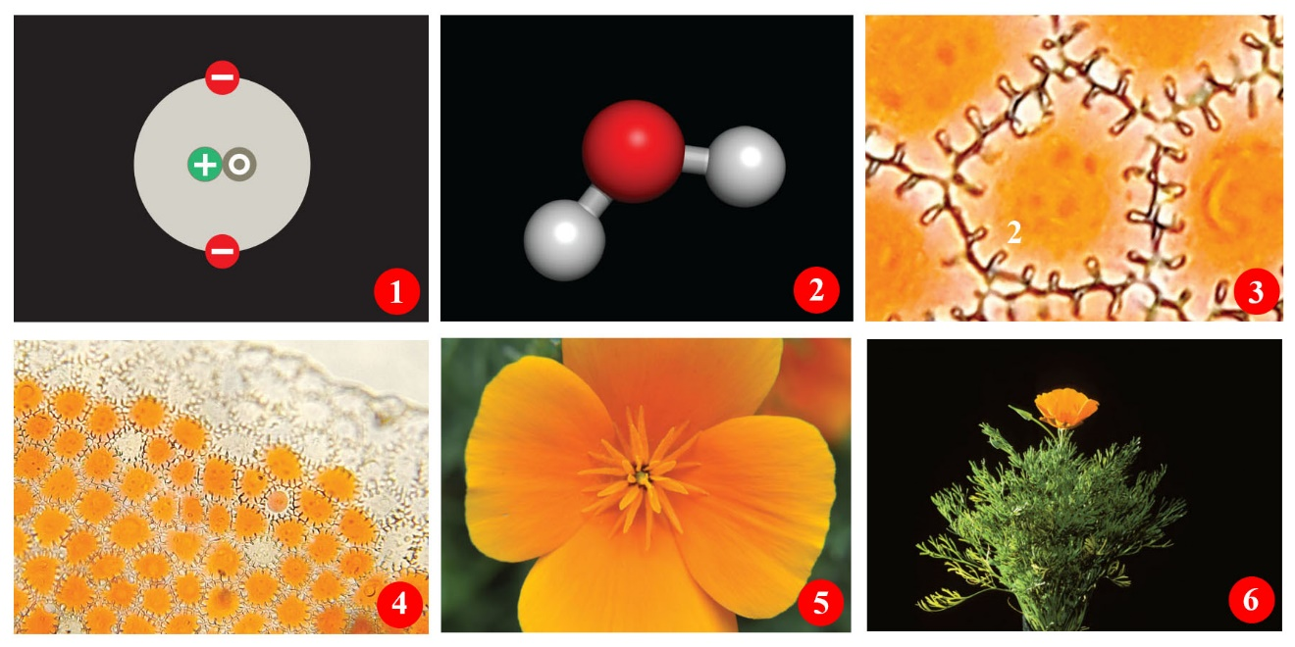
Figure 1.3

24. What is represented in frame 5 of Figure 1.3, illustrating the levels of life’s organization?
 | a. | Atom
 | b. | Tissue
 | c. | Molecule
 | d. | Organ
 | e. | Cell

25. Which organisms are NOT eukaryotes?
 | a. | Fungi
 | b. | Bacteria
 | c. | Mosses
 | d. | Fish
 | e. | Yeasts

26. In the experiment with peacock butterflies, the working hypothesis is that _____.
 | a. | silence confuses both predator and prey
 | b. | making sounds can provide a selective advantage to the prey
 | c. | eye spots attract the attention of predators.
 | d. | birds can find their prey by listening for their sounds
 | e. | unpalatable species display distinctive wings

27. Four of the following are key characteristics for the survival of a species. Which one is the exception?
 | a. | Ability to acquire energy and nutrients
 | b. | Response to environmental change
 | c. | Reproduction
 | d. | Inability to change
 | e. | Ability to grow and adapt through changes in DNA

28. Homeostasis provides what kind of internal environment?
 | a. | Positive
 | b. | Stable
 | c. | Limiting
 | d. | Changing
 | e. | Chemical and physical

29. Which characteristic is least applicable to the development of science?
 | a. | Evaluation of data
 | b. | Personal conviction
 | c. | Prediction
 | d. | Systematic observation
 | e. | Sharing of ideas

30. Which concept represents the lowest degree of certainty?
 | a. | Hypothesis
 | b. | Conclusion
 | c. | Fact
 | d. | Principle
 | e. | Theory

31. What is one of the independent variables in the peacock butterfly experiment?
 | a. | Presence of the wing spot
 | b. | Range of migration
 | c. | Species of bird predator
 | d. | Experimental location
 | e. | Percentage of survivors

32. Which term refers to the first explanation of a problem (sometimes referred to an "educated guess")?
 | a. | Principle
 | b. | Law
 | c. | Theory
 | d. | Fact
 | e. | Hypothesis

33. Which of the following is a substance that an organism needs for growth and survival but cannot make for itself?
 | a. | Sunlight
 | b. | Water
 | c. | Nutrient
 | d. | Chlorophyll
 | e. | ATP

34. Which is the least inclusive of the taxonomic categories listed below?
 | a. | Family
 | b. | Phylum
 | c. | Class
 | d. | Order
 | e. | Genus

35. Members of what group are multicellular producers?
 | a. | Animals
 | b. | Protists
 | c. | Fungi
 | d. | Plants
 | e. | Bacteria

36. Which term refers to judging information before accepting it as fact?
 | a. | Critical thinking
 | b. | Law
 | c. | Theory
 | d. | Fact
 | e. | Hypothesis

37. Which feature is not characteristic of all living organisms?
 | a. | All have requirements for energy.
 | b. | All must participate in one or more nutrient cycles.
 | c. | All have ultimate dependence upon the sun.
 | d. | All interact with other forms of life.
 | e. | All must reproduce inside of organisms of other species.

38. About twelve to twenty-four hours after the previous meal, a person's blood-sugar level normally varies from 60 to 90 milligrams per 100 milliliters of blood, though it may rise to 130 mg/100 ml after meals high in carbohydrates. That the blood-sugar level is maintained within a fairly narrow range despite uneven intake of sugar is due to the body's ability to carry out ______.
 | a. | adaptation
 | b. | inheritance
 | c. | metabolism
 | d. | homeostasis
 | e. | evolution

39. Living organisms are members of all of the levels listed below. However, rocks are components of _____.
 | a. | the community
 | b. | the population
 | c. | the ecosystem only
 | d. | the biosphere only
 | e. | both the ecosystem and the biosphere

40. Which group in the peacock butterfly experiment had the highest survival rates?
 | a. | Those with more nocturnal habits
 | b. | Those without spots and without hissing/clicking sounds
 | c. | Those without spots but with hissing/clicking sounds
 | d. | Those with spots and hissing/clicking sounds
 | e. | Those with the same flower habitat as the birds

41. Olestra chips did not cause cramps at a higher rate than normal chips. This is known as the ____ of this experiment.
 | a. | Hypothesis
 | b. | Prediction
 | c. | Control
 | d. | Conclusion
 | e. | Data

42. The conversion of solar energy to chemical energy is known as ______.
 | a. | metabolism
 | b. | photosynthesis
 | c. | chemosynthesis.
 | d. | catabolism
 | e. | anabolism

43. Which group is made up of almost exclusively decomposers?
 | a. | Plants
 | b. | Fungi
 | c. | Animals
 | d. | Bacteria
 | e. | Protists

44. What is the process of transmission of DNA to offspring that occurs during reproduction?
 | a. | Inheritance
 | b. | Development
 | c. | Growth
 | d. | Photosynthesis
 | e. | Homeostasis

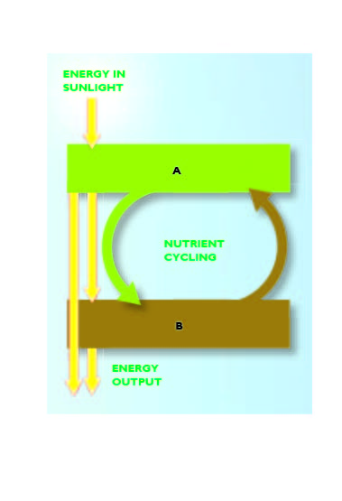
Figure 1.4

45. In Figure 1.4, "A" and "B" should be labeled, respectively, ____ and _____.
 | a. | consumers; producers
 | b. | decomposers; producers
 | c. | producers; redistributors
 | d. | producers; consumers
 | e. | consumers; decomposers

46. Which characteristic will NOT strengthen the validity of a theory?
 | a. | Repetitions of experiments
 | b. | Increased observations
 | c. | Time after the experiment
 | d. | Faith in the experiment
 | e. | Confirmation by many scientists

47. Four of the following characteristics are required for the life of an individual organism to continue. Which is the exception?
 | a. | To maintain chemical uniqueness and organization
 | b. | To respond to stimuli
 | c. | To possess a genetic program to control cell processes
 | d. | To reproduce
 | e. | To evolve

48. Which cell lacks a nucleus?
 | a. | Bacterial cell
 | b. | Fungus cell
 | c. | Animal cell
 | d. | Protist cell
 | e. | Plant cell

49. Which of the following is common term for a eukaryote that is NOT a plant, animal, or fungus?
 | a. | Specific epithet
 | b. | Protist
 | c. | Prokaryote
 | d. | Taxonomy
 | e. | Fungus

Figure 1.3

50. In Figure 1.3, illustrating the levels of life’s organization, what is represented in frame 3?
 | a. | Atom
 | b. | Tissue
 | c. | Molecule
 | d. | Organ
 | e. | Cell

51. What is the correct ordering in the hierarchal levels of the organization of life, from the least inclusive to the most inclusive?
 | a. | Atoms, tissues, cells, organs, and organisms
 | b. | Molecules, cells, organs, tissues, and organisms
 | c. | Ecosystems, populations, tissues, cells, and organs
 | d. | Cells, tissues, organs, communities, and populations
 | e. | Cells, tissues, organs, organisms, and ecosystems

52. What was the dependent variable in the peacock butterfly experiments?
 | a. | Changing predators
 | b. | Changing habitats
 | c. | Painting the wings
 | d. | Clipping the hindwings
 | e. | Getting eaten

53. Which phrase would most likely be used in a discussion of homeostasis?
 | a. | Respond to environmental stimuli
 | b. | Limited range of variation
 | c. | Rapid energy turnover
 | d. | Both respond to environmental stimuli and limited range of variation
 | e. | Both respond to environmental stimuli and rapid energy turnover

54. The control in an experiment _______.
 | a. | makes the experiment valid
 | b. | is an additional replicate for statistical purposes
 | c. | reduces the experimental errors
 | d. | minimizes experimental inaccuracy
 | e. | allows for comparisons to the experimental group

55. Which group includes all of the other groups?
 | a. | Domain
 | b. | Order
 | c. | Family
 | d. | Genus
 | e. | Species

56. What is a hypothesis?
 | a. | A report of the findings of scientific experiments
 | b. | A specific conclusion of an experiment in an "if … then" format
 | c. | A way of using isolated facts to reach a general idea that may explain a phenomenon
 | d. | The summary of the outcomes of scientific findings
 | e. | A testable explanation of a natural phenomenon

57. What characteristic is common to all living things?
 | a. | All living things eat.
 | b. | All living things are producers.
 | c. | All living things sense and respond to change.
 | d. | All living things have a nucleus.
 | e. | All living things are consumers.

58. Scientific work involves ______________________________.
 | a. | the natural and supernatural world
 | b. | retesting theories frequently for verification
 | c. | proving theories with absolute certainty
 | d. | testing hypotheses under every possible circumstance
 | e. | coming up with the best objective descriptions of reality

59. A(n) ____ property is a characteristic of a system that does not appear in any of its component parts.
 | a. | symbiotic
 | b. | emergent
 | c. | synergistic
 | d. | energetic
 | e. | living

60. The smallest unit of life that can exist as a separate entity is a(n) ___________.
 | a. | cell
 | b. | molecule
 | c. | organ
 | d. | population
 | e. | ecosystem

Classification. Match the following descriptions with the most appropriate group listed below.
a. | Bacteria
b. | Protists
c. | Plants
d. | Fungi
e. | Animals

61. Multicellular producers

62. Prokaryotic

63. Unicellular organisms of considerable internal complexity

64. Multicelled mobile consumers

65. Based on fossils, oldest, still living organisms

66. Unicellular eukaryotic producers

67. Most common multicellular decomposers

Classification. Match the following descriptions to the most appropriate function, process, or trait listed below.
a. | Inheritance
b. | Reproduction
c. | Photosynthesis
d. | Growth
e. | Homeostasis

68. A process found only in plants, some bacteria, and some protists

69. A characteristic most organisms exhibit that tends to keep their internal environment within a range that favors survival

70. The transmission of DNA from parent to offspring

71. Process by which individuals produce offspring

Match the following letters to the number with which they best correspond.
a. | Observation
b. | Question
c. | Hypothesis
d. | Prediction
e. | Law of nature
f. | Scientific theory
g. | Assessment
h. | Report

72. This is a generalization that describes a consistent natural phenomenon for which there is incomplete scientific explanation.

73. People who regularly consume sugary drinks with their meals will have a higher likelihood of being obese than people who do not.

74. Submit the results and the conclusions to the scientific community.

75. Hypothesis that has not been disproven after many years of rigorous testing.

76. Compile test results and draw conclusions from them.

77. Drinking sugary drinks leads to obesity.

78. What are some causes of obesity?

79. Obesity rates are increasing.

Answer Key
1. a

2. a

3. c

4. e

5. b

6. d

7. b

8. c

9. b

10. c

11. d

12. b

13. e

14. d

15. c

16. e

17. d

18. a

19. e

20. c

21. b

22. a

23. a

24. d

25. b

26. b

27. d

28. b

29. b

30. a

31. a

32. e

33. c

34. e

35. d

36. a

37. e

38. d

39. e

40. d

41. d

42. b

43. b

44. a

45. d

46. d

47. e

48. a

49. b

50. e

51. e

52. e

53. b

54. e

55. a

56. e

57. c

58. e

59. b

60. a

61. c

62. a

63. b

64. e

65. a

66. b

67. d

68. c

69. e

70. a

71. b

72. e

73. d

74. h

75. f

76. g

77. c

78. b

79. a

