Chapter 1

Answers to Exercises 1
- The feature data set is called Transportation. It has two feature classes, majroads and interstates.
Method: Use the Add Data button to look at the usdata geodatabase.
- The coordinate system of interstates/majroads is North America Equidistant Conic.
Method: Open the layer properties in the Table of Contents and examine the Coordinate System tab.
- There are 3142 counties in the United States, 58 of them are in California.
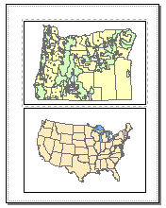Method: Open the attribute table for counties and do a query for STATE_NAME = ‘California’
8
- The largest lake is Lake Superior. It is 32,213 mi².
Method: Open the attribute table for the lakes feature class and sort the Area field to find the largest lake.
- Mississippi contains the county Itawamba.
Method: Open the county attribute table and use Find to locate Itawamba in the table.
- The average 2014 state population density is 388 people/sq mi. The minimum is 1.3 and the maximum is 10,116.
Method: Open the states attribute table, right-click the POP14_SQMI field and choose Statistics.
- 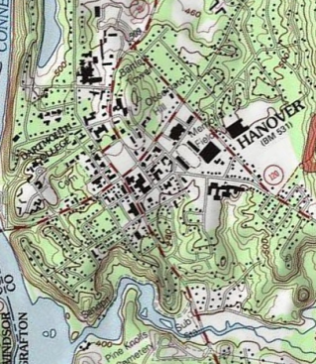The other four feature class types are annotation, dimensions, multipoints, and multipatches.
9
Method: Open Help and type “feature classes” in the Search tab. Find the feature class basics entry.
- See map.
Method: Create two data frames and arrange them on the page. Activate one, add the required data, and set the symbols. Repeat for the second.
- Answers will vary; see map for example using Dartmouth College.
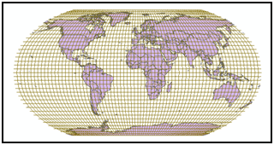Method: Search for ‘topo’ and add the USA Topo Maps service to the map. Zoom to the campus.
10
- See map.
Method: Add the feature classes to a new blank map. Open the Layers data frame properties and choose the Predefined > Projected > World > Robinson coordinate system.

Answer to Challenge Problem 1
Answers will vary.

Chapter 1

Answers to Review Questions 1
- A feature is a single spatial object and could be a point, line, or polygon. A feature class is a collection of similar features with the same attribute fields. A feature data set is a collection of feature classes that share a common theme and coordinate system.
- There are 3 feature classes, 650 features, 3 attribute tables, and 650 records in the database.
- Rainfall, temperature, and slope are continuous data types. Voting districts, soil types, and vegetation types are all discrete data types for categorical data.
- The two GPS units are set to record location in different coordinate systems. To get matching locations, one would need to set his/her unit to record in the same coordinate system as the other.
- Vector would be a better choice. Vector can store features with greater precision, important when storing property boundaries. Vector can store multiple attributes for each parcel. Vector can store the parcel data more efficiently with less storage space for the same resolution in raster.
- The length of field in inches is 100 yd × 36 in./yd = 3600 in. Set up the ratio 0.5 in./3600 in. = 1/x, yielding x = 7200. The scale is thus 1:7200.
- The boundary is being located by the GPS with a relatively high precision, so I would consider it precise. However, interpreting the location of the boundary is subjective, and the boundary itself may move over time depending on climate and precipitation, so the accuracy is not that high.
- The crop field can be well defined for a single moment in time as it is very clear what is growing. However, the crop type could change from year to year. The organic matter value of the soil probably changes from place to place within the field, and may also vary from year to year, and so can only be considered a representative value. Knowing how it was determined might be important.
- GIS servers can only be accessed over the Internet, so a connection must be available. Many GIS servers provide only the data requested rather than the entire data file. GIS services can be used by many kinds of devices, not just a Windows computer. GIS servers have more sophisticated security measures than local data.
- Mastering ArcGIS ,Tutorial Data 7th edition (2015) [DVD-ROM]. McGraw-Hill Higher Ed: Dubuque, Iowa.

Answers to Tutorial Questions 1
- The county name is Wallowa.
- There are 36 rows in the table.
- The smallest county is named Wheeler.
- The name of the MapTips field is NAME.
- The NOAA National Weather Service provides the information, and the USGS hosts the GIS server.

Answers to Exercises 1
- The feature data set is called Transportation. It has two feature classes, majroads and interstates.
Method: Use the Add Data button to look at the usdata geodatabase.
- The coordinate system of interstates/majroads is North America Equidistant Conic.
Method: Open the layer properties in the Table of Contents and examine the Coordinate System tab.
- There are 3142 counties in the United States, 58 of them are in California.
Method: Open the attribute table for counties and do a query for STATE_NAME = ‘California’
8
- The largest lake is Lake Superior. It is 32,213 mi².
Method: Open the attribute table for the lakes feature class and sort the Area field to find the largest lake.
- Mississippi contains the county Itawamba.
Method: Open the county attribute table and use Find to locate Itawamba in the table.
- The average 2014 state population density is 388 people/sq mi. The minimum is 1.3 and the maximum is 10,116.
Method: Open the states attribute table, right-click the POP14_SQMI field and choose Statistics.
- The other four feature class types are annotation, dimensions, multipoints, and multipatches.
9
Method: Open Help and type “feature classes” in the Search tab. Find the feature class basics entry.
- See map.
Method: Create two data frames and arrange them on the page. Activate one, add the required data, and set the symbols. Repeat for the second.
- Answers will vary; see map for example using Dartmouth College.
Method: Search for ‘topo’ and add the USA Topo Maps service to the map. Zoom to the campus.
10
- See map.
Method: Add the feature classes to a new blank map. Open the Layers data frame properties and choose the Predefined > Projected > World > Robinson coordinate system.

Answer to Challenge Problem 1
Answers will vary.

